iF Foundation Haiti 2020 Annual Report
January 2021
Table of Contents
Executive Summary 2
Agricultural Program 2
Farm Input Program 1
Research 6
Own Production 6
Breakfast Program 8
Other Highlights 9
Internship 9
Collaborations 11
Audit 11

EXECUTIVE SUMMARY
Year 2020 marked the seventh anniversary of the iF Foundation’s agricultural program. The Frank and Raffaela Iovino Center opened its doors in July 2013, which launched the Foundation’s journey into agriculture. We conducted our first crop campaign in October 2013 and our eleventh crop campaign, completed in November 2020, was the most successful season to date. Last year was particularly challenging because of the Covid-19 pandemic, which impacted not only the physical health of people but also their economic and social wellbeing. However, amid all the struggles, there were small victories, joys, and successes. The staff and management of the iF Foundation saw our efforts rewarded with the successes experienced by the majority of our beneficiary farmers.
At the inception of the program, the Foundation supported farmers for a diverse variety of crops including corn, bean, rice, and peanut, to which we later added vegetables. However, due to issues associated with irrigation, mechanization, and marketing, we suspended campaigns for corn (2015), beans (2015), rice (2018), and vegetables (2018) pending better growing and market conditions. As a result of our collaboration with New Roots, an institution involved in poultry production, we were able to secure a contract for corn production, allowing us to resume supporting farmers for this crop. The last campaigns of 2020 focused on corn and peanut production.
2020 Achievements
- AGRICULTURAL PROGRAM
The iF Foundation’s agricultural program has three components: financial support for farm inputs, the research, and the iF Foundation’s own production.
- Farm Input Program
Farmer support provides 0% interest loans to farmers for inputs (land preparation, etc.), technical assistance, and marketing support through harvest and post-harvest. This year, the program worked with 301 farmers (including 21% women) for peanut and corn in ten (10) different localities, planting 130.97 ha of land. Of these 301 farmers, 70 produced corn on 32.42 ha of land and 231 produced peanuts on 98.55 ha of land.
As previously noted, the program offers marketing support to farmers to facilitate the sale of their harvest. The iF Foundation serves as a bridge between farmers and buyers, negotiating contracts on their behalf. We also help farmers to meet buyers’ requirements by providing free aflatoxin testing. We also provide free transportation for their production and implement improved post-harvest technologies (mesh bags, tarps etc.) to protect the product integrity and marketability. Our laboratory tests the field output for each farmer to ensure that they meet quality standards. New Roots produces chicken feed with the corn purchased from our farmers, thus the safety of raw materials is paramount. They require aflatoxin levels to be less than 20ppb to qualify for purchase. Our largest peanut buyer is MFK (Meds & Foods for Kids), which produces therapeutic food for children suffering from malnutrition. The aflatoxin for them is less than 10ppb per UN requirement. We tested the harvest of 263 farmers during the last campaign. Of these, only 22 did not meet the aflatoxin limit (see table for more details). The failure rate of 8.37% represents a significant decrease compared to last season (13.49%). This improvement is a direct result of the technical support iF provides to participating farmers. The total quantities brokered by the Foundation for our farmers were 14,739.68 kg of corn (all sales to New Roots) and 40,098.59 kg of peanuts (33,338.3 kg sold to MFK). This represents a record year for both corn and peanuts.
For the 2020 campaign we had a loan reimbursement target of 80%. The actual reimbursement rate was 89.17%, which is the highest reimbursement rate to date. Several localities achieved a reimbursement rate of 100%. Despite all the issues we encountered (lateness in land preparation and planting, lack of rain), the season was a great success. Breaking it down by crop, corn farmers reimbursed 84.55% of their loans and peanut farmers reimbursed 90.57% of their loans.
The main objective of the program is to help farmers operate as a business and generate enough profit to meet basic family needs (education, health, nutrition, etc.). Besides the inputs paid for using loans from the Foundation, farmers incur many other expenses including planting, weeding, harvesting, etc. to successfully bring a crop to harvest. It is important for us to collect data during and after the growing season to calculate if farmers generate enough revenue to cover their expenses and make a profit. We surveyed 247 farmers of the 301 loan recipients after the season ends to get an accurate accounting of total expenses and revenue. The data showed that farmers made an average net revenue of 15500.00 HTG and a maximum net revenue of 85000.00 HTG.

Successful Farmer Highlight
This season we had many farmers who enjoyed success. The biggest payout to a one farmer, Jean L. Oreste, was 107,175.00 gourdes. He lives in Dericourt and has participated in the program for the last 3 seasons. Jean has always been one of our better performing beneficiaries since he started with the program but this season was his best. His net profit was 85,775.00 gourdes. When our farmers succeed, it increases iF staff and management motivation to make next year even better.
The year 2020 saw the Foundation and its farmers achieve the highest reimbursement rates, and produce and sell the largest harvest, and generate the highest net beneficiary profit.
- Research
Research activities this year were limited. Our main activity was the multiplication of biofortified corn in collaboration with CIAT. The multiplication was done on 0.23 ha of land and produced 338 kg after drying, threshing, and sorting. Part of the harvest was kept as seed for further multiplication, and the remaining harvest was sold to New Roots. The future plan for this cultivar is to manage its integration in the Haitian diet, starting with our farmers, as bio-fortified crops are an important part of the solution to chronic micronutrient deficiencies in malnourished populations.
Picture 1- Bio-fortified corn harvest
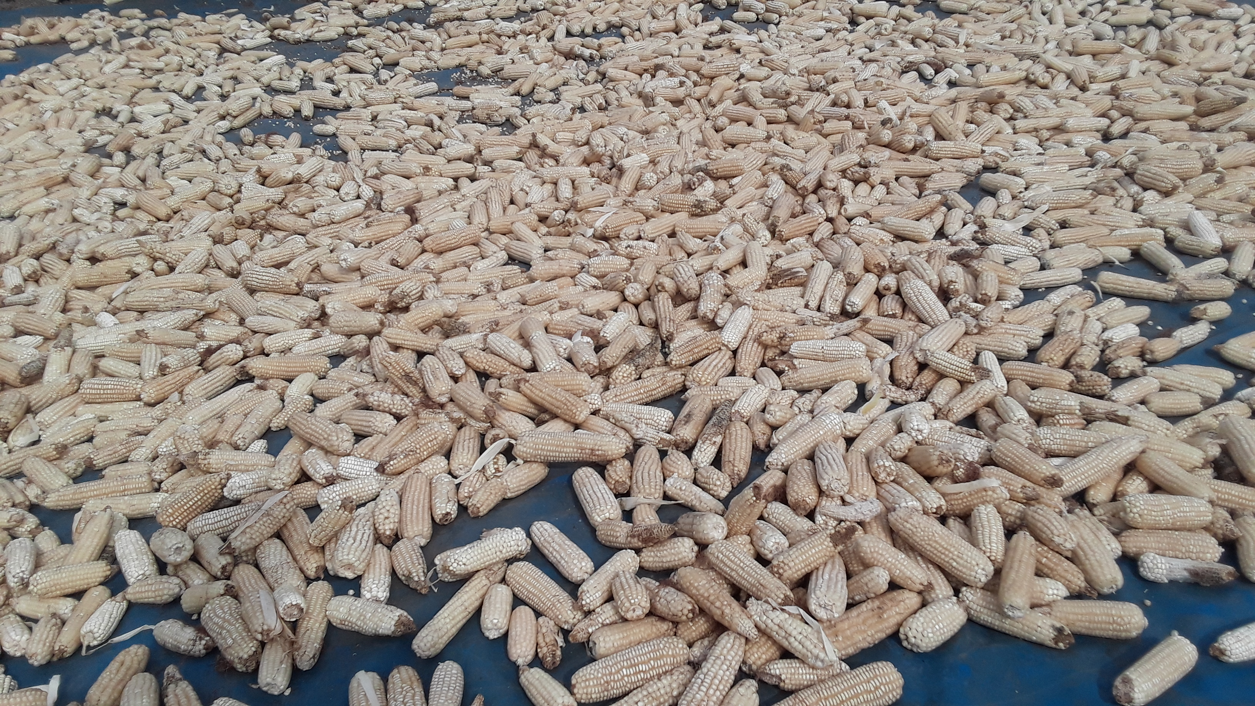

- Own Production
The iF Foundation fields are used for research, and production of row crops, vegetables, seed, and fruit trees. The Foundation produces its own vermicompost (9.5MT this year). We also manage a nursery producing grafted fruit tree seedlings. The Foundation orchards have started producing fruits, after years of severe drought. We expect production to ramp up significantly in subsequent years, now that the trees have had sufficient time to develop root structure and adapt to current growing conditions. The harvest collected starting on September 22 was 1810 kg:
Picture 2. Morenga Seedlings in the Nursery
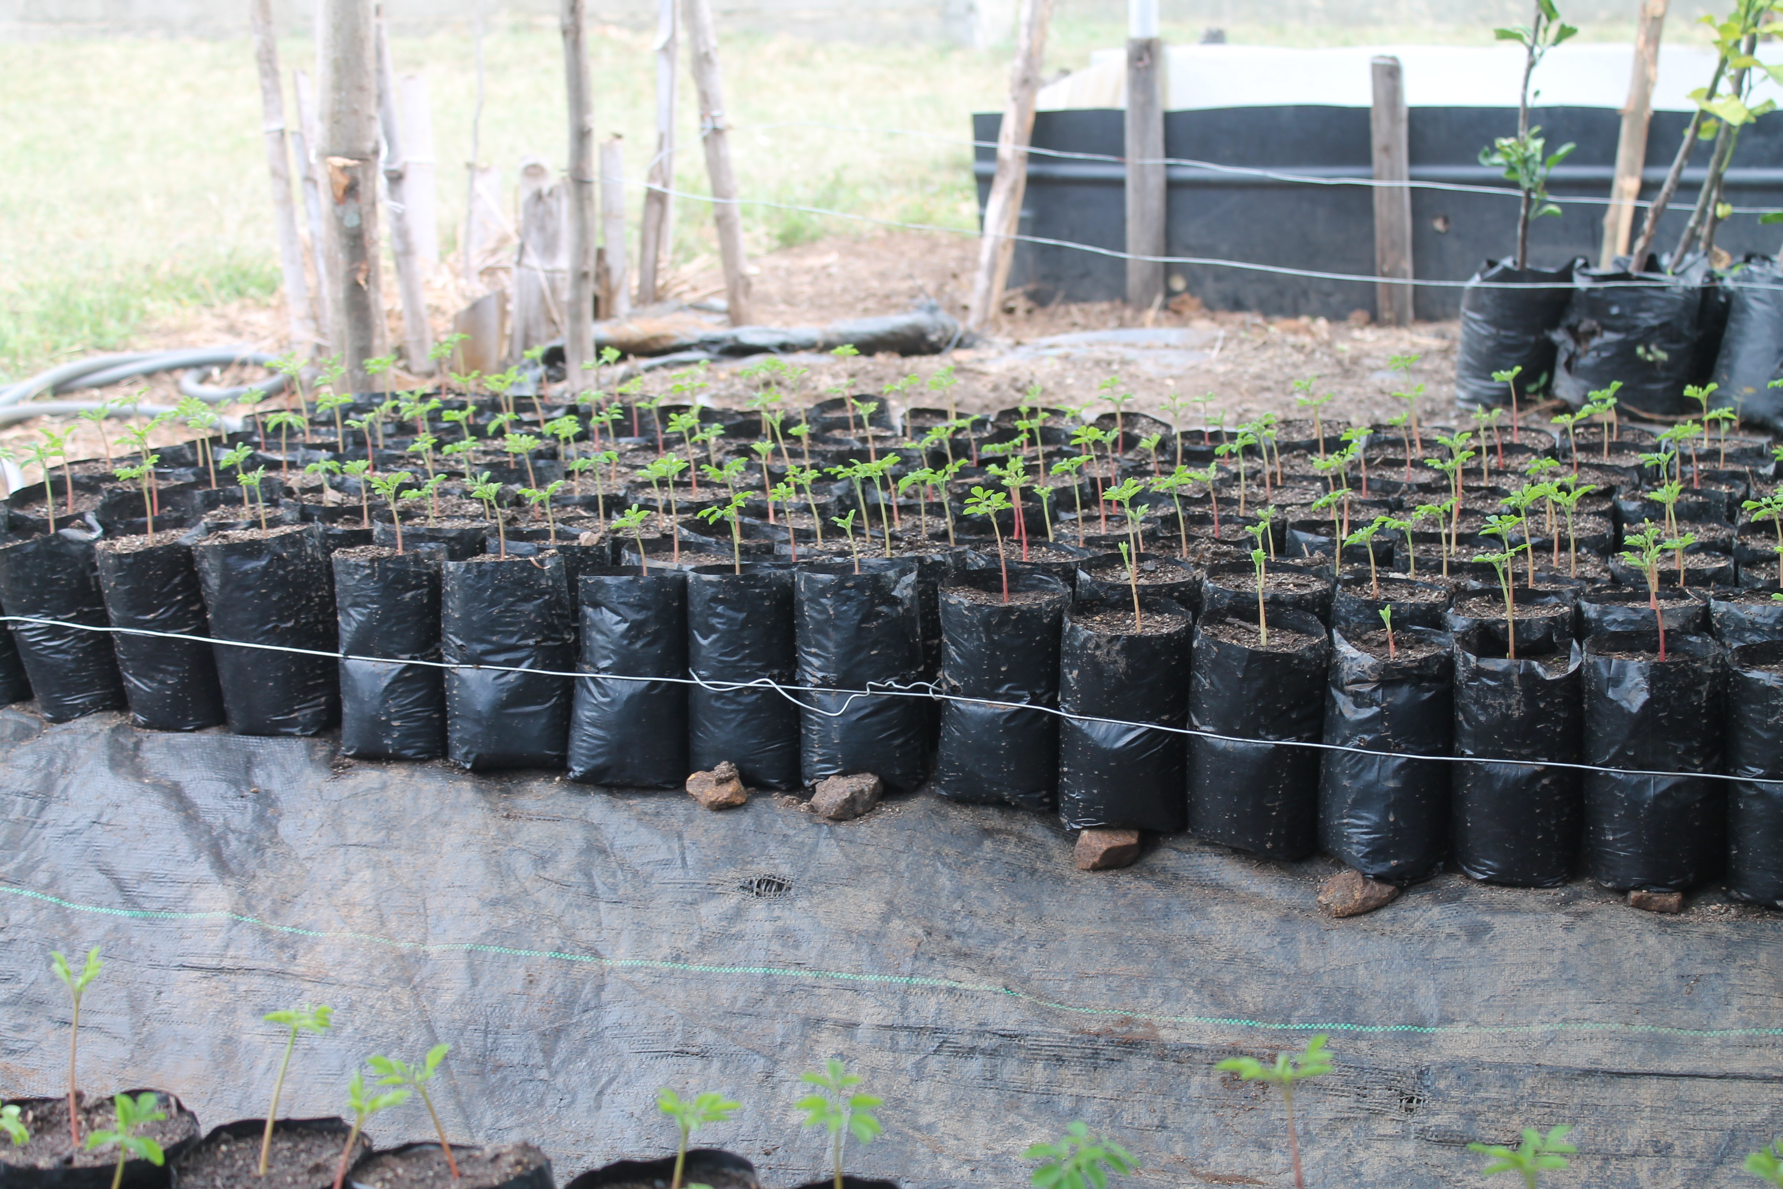
- BREAKFAST PROGRAM
The breakfast program was greatly impacted by Covid-19, because all schools were closed for three months (April-June). The school year resumed in August and ran smoothly for the remainder of 2020. The closure prevented the Foundation from meeting its goal for sandwich delivery. Food was provided to 3417 children at 18 schools, and we delivered 313092 sandwiches.
This year, the breakfast program produced its own peanut butter including mechanical roasting and milling. Previously, we had to outsource those services, which increased the risk of aflatoxin contamination during processing.
Picture 3 – Sandwich Delivery Picture 4 – Sandwiches Preparation
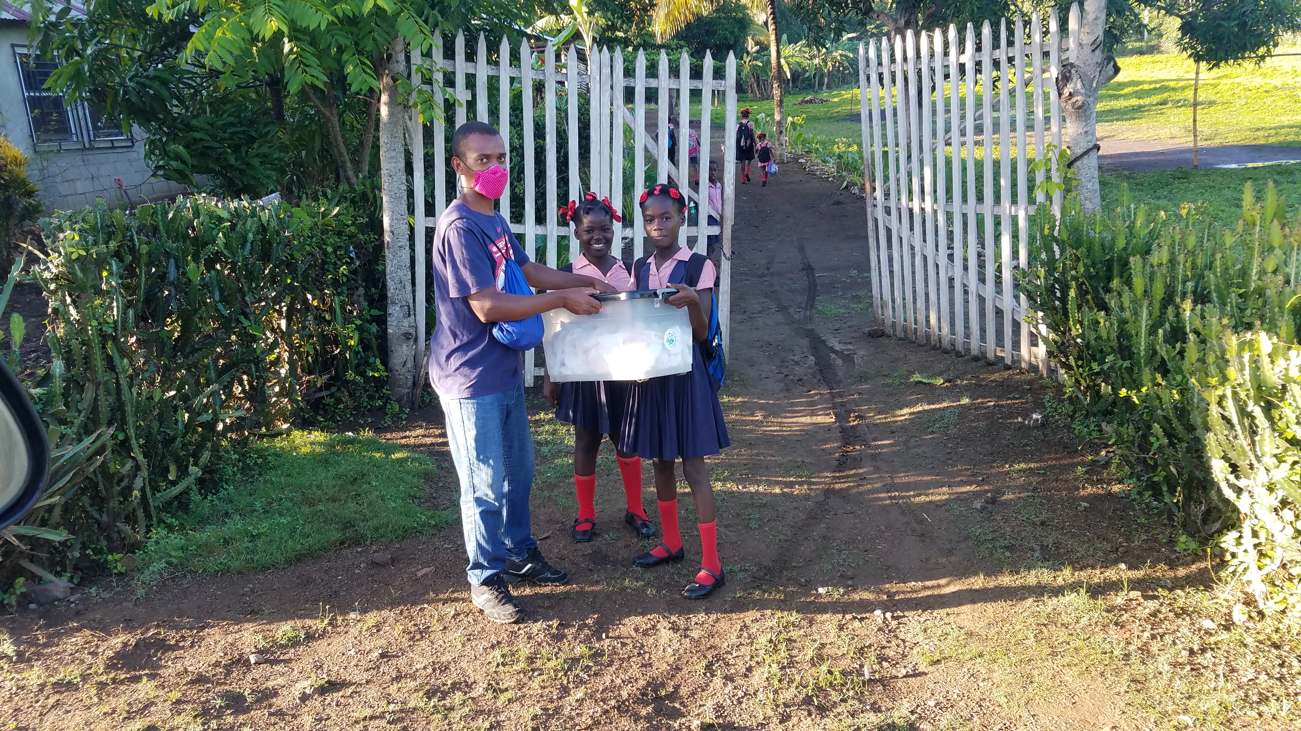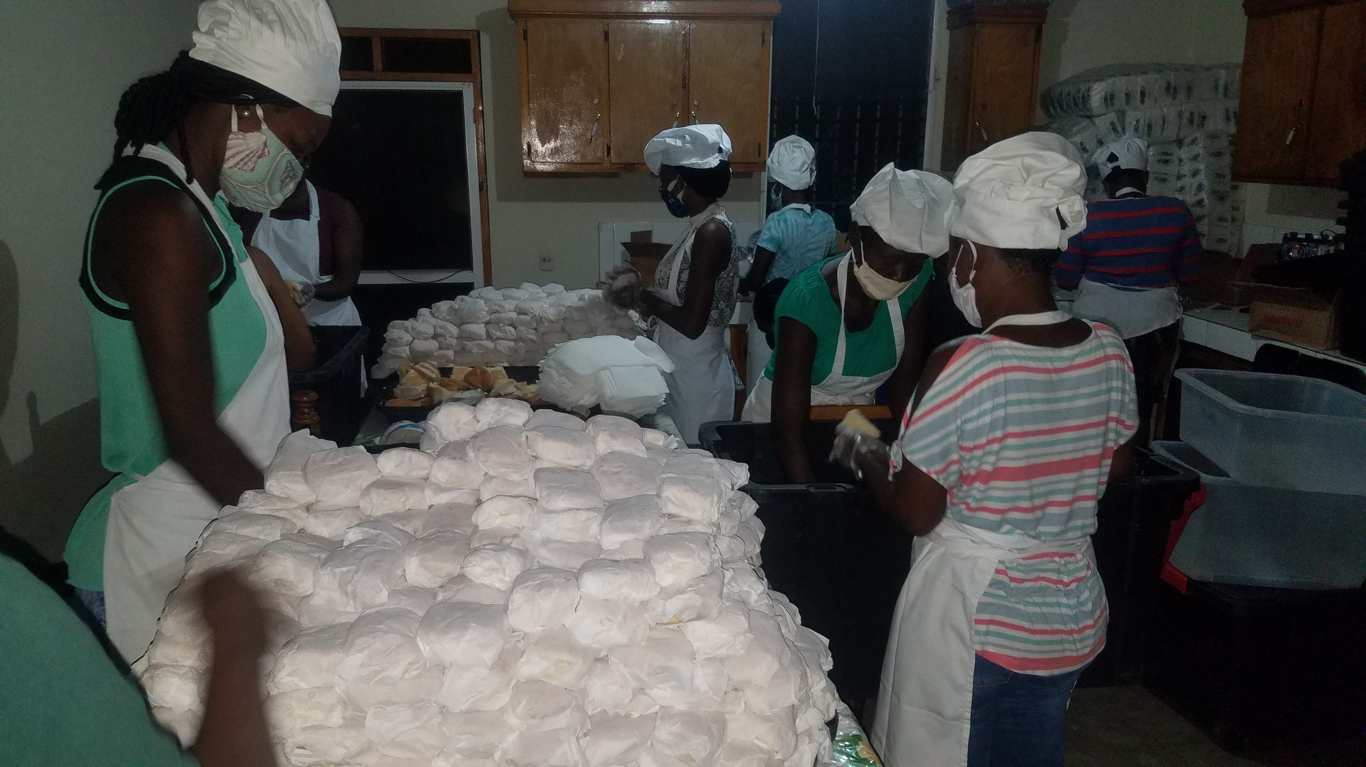

- OTHER HIGHLIGHTS

- Internship
The iF Foundation established its internship program in 2014. Every year we host a number of students from different universities (foreign and domestic). We provide a platform for the students (local students in particular) where they get to apply the didactic knowledge acquired in the classroom. Often we learn from them as they learn from us. This activity was also impacted by Covid-19, as universities were closed for a period of time. We were able to receive a number of students by the end of the year. These students perform basic fieldwork and learn new skills, including composting, grafting, and laboratory testing (aflatoxin testing, microbiology tests, etc.). For year 2020, we received 61 students from five programs.
The iF Foundation’s internship program has received positive feedback from student participants and university administrators every year it has operated. Students are eager to win an internship at the iF Foundation, and it has become very competitive to earn a slot. They love the work and appreciate the experience they gain. One intern, Rose Myrlande, offered this testimonial:
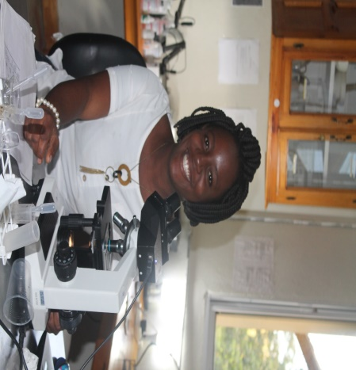
“The experience at iF Foundation was a great opportunity for me, because I had the opportunity to acquire a lot more of the concept, namely vermicomposting, how to prepare it how to proceed in the laboratory to determine after harvest the various micro-organisms present therein.”

- Collaborations
Covid-19 reduced our interactions with outside organizations. We maintained our lonstanding relationship with MFK for the purchase of peanuts, the Ministry of agriculture for land preparation services to augment our own capacity, FOKAL for institutional and financial support, and local universities for the internship program. New Roots is out newest collaboraor. We also maintain an active technical partnership with CIAT in Colombia. Zamir Libohova, a soil scientist from the USDA Kellog Lab in Lincoln, Nebraska visited the technical center in March 2020 to do soil characterization at several locations within our intervention area. He collected 72 samples, which were then shipped to his lab in Lincoln for structural analysis. These 72 samples were also chemically analyzed by GMS Labs in Illinois through our ongoing collaboration with Soil Biotics. These analyses will help generate the data required to guide decision-making in future agricultural projects.
- Audit
The iF Foundation in Haiti conducted a formal audit in May 2020, funded by FOKAL. The main purpose for the audit was to produce audited financial statements. However, the audit also allowed us to detect some weaknesses within our internal control system. As a result, we hired an independent consultant to help us implement the auditor’s recommendations and reinforce our internal controls.
In summary, year 2020 was successful by all measures, despite the difficulties caused by the pandemic and climate change. We enter 2021 administratively stronger with greater optimism for our farner and student beneficiaries. As with every year, 2020 was a great learning experience, giving us additional skills and confidence to face the future.

